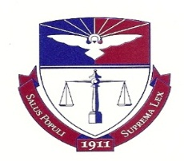
Duquesne University School of Law

Career Services Handbook Overview

Looking for job search and career advice? Thinking about revising your resume or cover letter? Your CSO Handbook is just a few clicks away on the CSO web site: http://www.duq.edu/law/career-services/handbook.cfm.

Chapters
*Preface and Introduction
*Fundamentals of Job Seeking
*Timing Recommendation – When You Should Be Doing What
*Mechanics of a Job Search
*Cover Letters
*Resumes
*Interview Skills
*Follow-Up Correspondence
*Negotiating Compensation
*Writing Samples
*Professionalism
*High-Tech Etiquette
*LinkedIn Tip Sheet
*How to Be Successful in Your Job

Appendices

*Alternative Careers Web Sites

*Sample Questions for Clerkship Interviews

*600+ Things You Can Do With A Law Degree (Other Than Practice Law)

*Federal Government Employment Web Sites

*Pennsylvania Government Employment Web Sites

*Placement Firms

If you would like to schedule an appointment about your job search or career advice, contact the CSO at lawcareers@duq.edu or 412-396-6559 to schedule an appointment.

