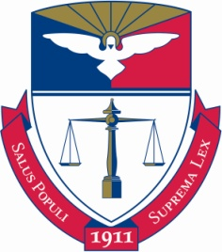
Maria Comas, Esq., Career Services Director
Arlene Miller, Administrative Assistant

Address: Career Services Office, Duquesne University School of Law
209 Hanley Hall, 900 Locust St., Pittsburgh, PA 15282
Website: www.law.duq.edu/career
Email: lawcareers@duq.edu
Phone: (412) 396-6559
Fax: (412) 396-6598
Scholarship

*************************************************************************************************************
Sarita and Claire Lucas Foundation
*************************************************************************************************************
Announcement

Title: Sarita and Claire Lucas Foundation Scholarship
Topic Area: Public Interest
Deadline: Thursday, December 01, 2016
Contact: Sarita and Claire Wright Lucas Foundation
E-mail: info@saritaandclairefoundation.org
Financial Award: Do not usually exceed $5,000

Description:

The Sarita and Claire Lucas Foundation Scholarship is a competitive scholarship program that makes annual awards to qualified, outstanding graduating African American female law students. The scholarship was established in 2015 and is named after Sarita Wright Lucas and her daughter Claire in recognition of Sarita’s integrity and passion for justice.

Sarita and Claire Lucas Foundation Scholarships are awarded to help African American female students with the costs associated with preparing for and taking the Delaware Bar Exam. These women, like Sarita, should have an interest in pursuing careers in prosecution.

Awards generally do not exceed $5000.00.

Students who are interested in applying for the Sarita and Claire Lucas Foundation Scholarship are strongly encouraged to review the eligibility criteria and program description before submitting an application.

Beginning September 9, 2016, our PDF application will be available for download for the upcoming bar exam year. Please note: Applicants must download the Foundation application form, and mail completed form to the address below along with your supporting documents. If you are unable to download the application, please send a note of inquiry to the scholarship program at info@saritaandclairefoundation.org.

Sarita and Claire Wright Lucas Foundation
P.O. Box 171031
Boston, MA 02116

